Custom Physics Shape

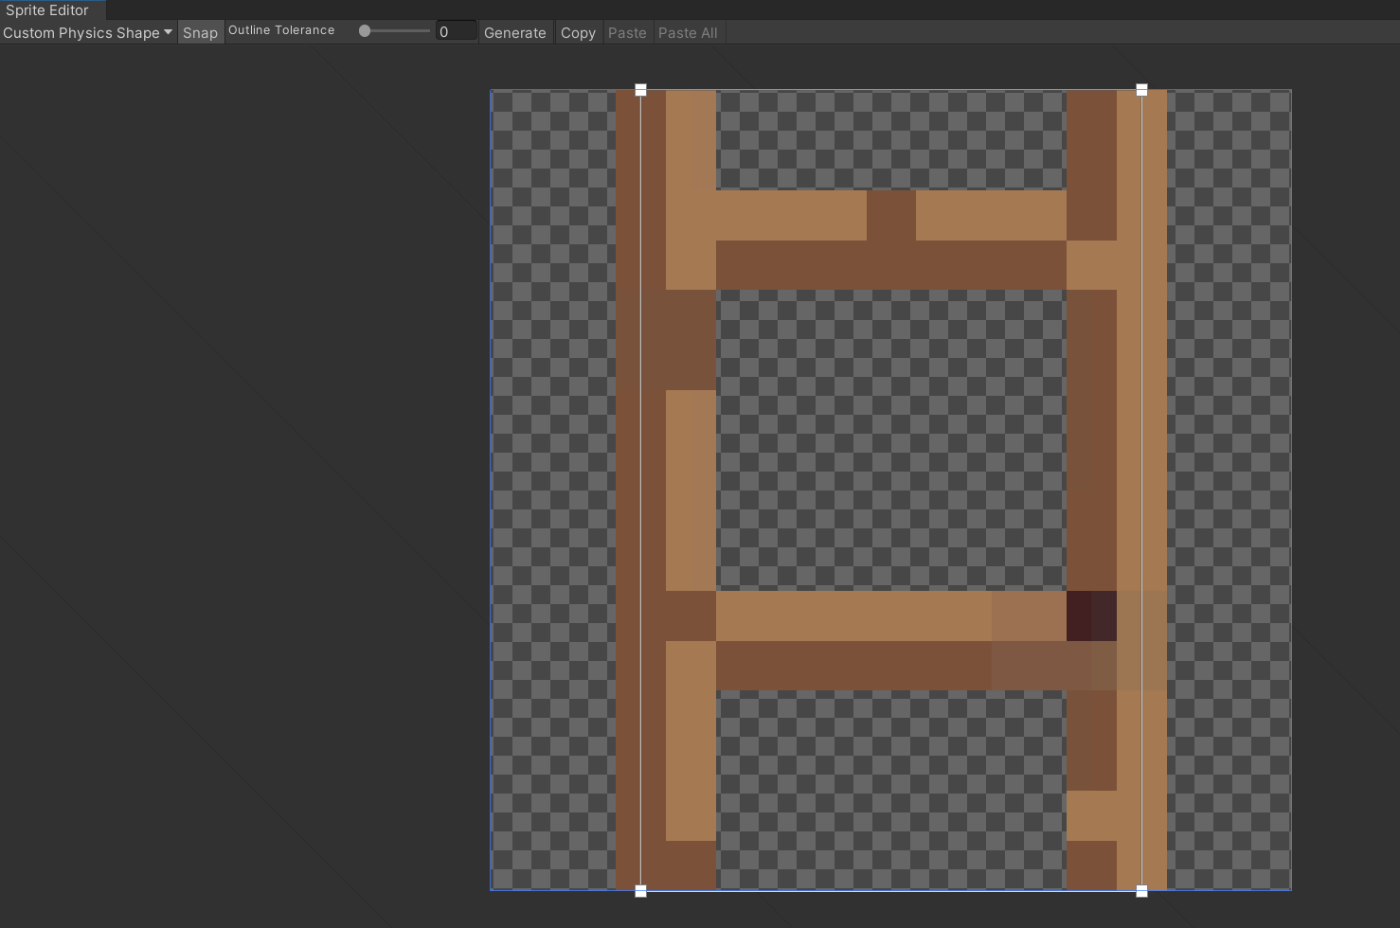

Custom physics shapes can be used to give art an custom desired shape for the colliders to take shape as custom physics shape.